**Ambidexterity**

Let’s say A & B represent one hemisphere, while C & D represent the other.

Let’s say B & C represent corticocortical neurons, while A & D are local.

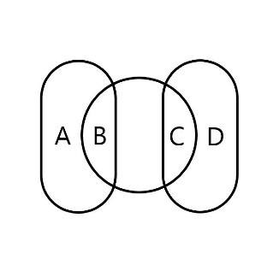

The center section between B & C represents the Corpus Callosum, consisting of 200–300 million *axonal projections1*, compared to the 100 billion2 *neurons*, interconnected via the number of synapses they share between hemisphere. That is to say, that the number of cells which make axonal projections across hemispheres is relatively small compared to the number which those cells themselves communicate with, and generally serve higher functions.

The relative higher importance of corticocortical neurons can be gestured towards by calculating the global maximum connection count for a set given those relationships, which is all the neurons of A, times all the neurons of B, times all the neurons of C, times all the neurons of D. Learning to use both hands equally can increase the CC by as much as 10%3, effectively raising throughput across a bottleneck. This is why putting the effort in to learn to engage fine motor skills and linguistics with both hands is valuable for time spent doing so.

Granted, these proportions and relationships are rudimentary and need to be completely refitted and scaled, but the general idea is that although a 10% increase from B1 and C1 (10 to 11) represents the same global increase as a 10% increase in A2 and D2 (50 to 55), the proportional growth is less in terms of neurons by count it took to make the increase, which means higher return for cost of growth, theoretically.

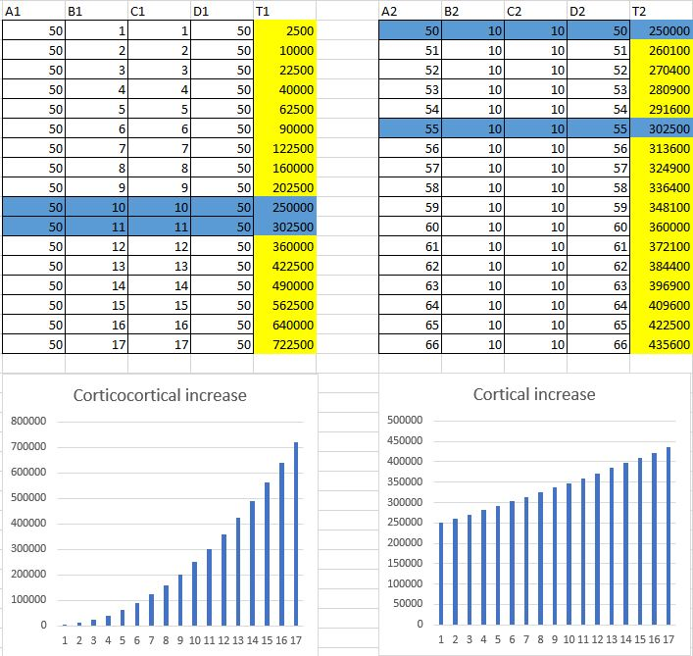

1. <https://en.wikipedia.org/wiki/Corpus_callosum>
2. <https://www.ncbi.nlm.nih.gov/pmc/articles/PMC2776484/>
3. <https://pubmed.ncbi.nlm.nih.gov/4023705/>